Using the Program
- Pre usage of the software
  - Make sure that you have your necessary objects. This includes red dots that are on the end points of your arms. In my case I have a dot with a safety pin for each shoulder and a cloth that wraps around each hand. Also I have a yellow dot for each bend point of the arms. So one for each side. See illustration below.
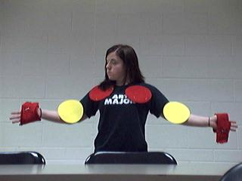
  - Once you have got the person set up. Make sure that you are in an environment that does not have any red or yellow. As you can see above I have a white wall behind me. I have also found that shinny surfaces can cause issues e.g. a white board.
  - Next hook up the camera you are going to use. I had a usb camera and a camera on my laptop to chose from. Give your machine enough time to install your camera if you are connecting one, else it may not be recognized or may cause the program to fail.

- Using the program
  - Once set up press start and the camera will start its feed. On the left is what it is seeing and on the right is the output generated by the program.
  - To make the program very efficient I have video format RGB 24 and a resolution of 320 x 240.
    - NOTE – The program needs for the video format to be RGB24 and is anticipated that it is.
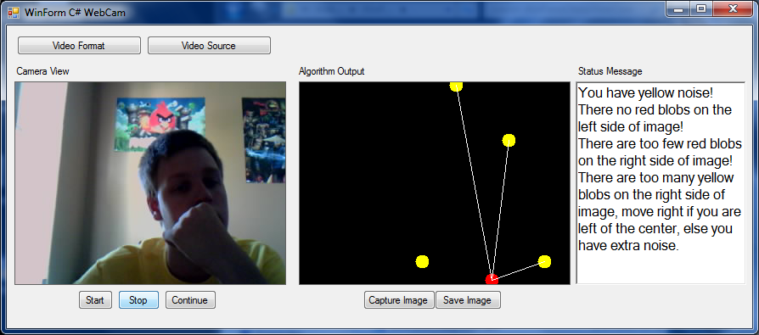
  - When you click the video format button, the box below will appear and all for you to change the settings.
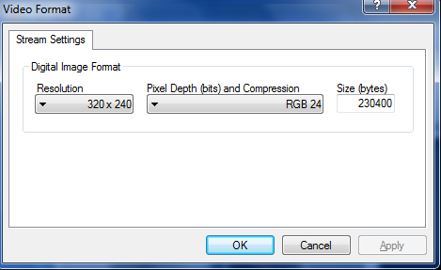

  - The video source button allows for the user to choose where the picture is coming from. So this can be a built in camera or an attached camera.
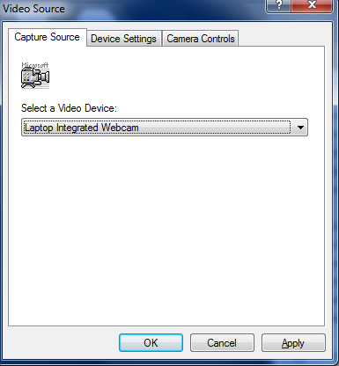
  - Final note about both the buttons that pertain to the camera features and choices, the camera must be started in order to get the options or buttons to respond. This was inherited from the existing code I picked up and never needed to change it.
- Finally using the program
  - After all setting are set and you have your objects on and the environment is suitable you can now start using the software.
    - In order for the program to draw correctly it will be looking for 2 red dots and a yellow dot on each side of the image. Image is split down the center, somewhat of a invisible divider. This allows for the program to draw easily and understand the data it is finding.
    - Once you are in the center the program will draw what it is finding and alert you if there are any issues. If issues are found it will tell you what it thinks is the problem.
    - If all is fine the program will draw you as a stick figure and track your motion in real time. Special feature is the smiley face that is drawn when all is interpreted well and the frowny face if it is not.

